Introduction
After being posed the question are male drivers better than female drivers, I have been asked to investigate this statement. Whilst other factors may affect someone’s ability to drive I will use the data provided of reflex and concentration times to try to explore this statement.
Specific behaviours | Marks
Provides a simple introduction of the question | 1
Restates question in their own words | 1
Mentions reflexes and concentration as two measures of driving ability | 1
Total | /3
Numerical analysis
 |  | Dominant  Hand | Concentration Activity
Females
(f) | Mean | 0.38 | 42.77
 | Median | 0.36 | 41.00
 | Standard Deviation | 0.07 | 12.94
Males | Mean | 0.35 | 43.33
(m) | Median | 0.35 | 42.00
 | Standard Deviation | 0.06 | 9.61

 | Female dominant | Male dominant | Female  concentration | Male  concentration
Minimum | 0.3 | 0.14 | 19 | 30
Q1 | 0.34 | 0.31 | 34 | 36
Median | 0.37 | 0.35 | 40.5 | 42
Q3 | 0.43 | 0.37 | 47.75 | 47.75
Maximum | 0.56 | 0.51 | 61 | 64

Specific behaviours | Marks
Calculates measures of central tendency including mean, median & mode | 1
Calculates mean, median with outliers removed | 1
Calculates range | 1
Calculates standard deviation or inter-quartile range | 1
Calculates standard deviation and IQR | 1
Total | /5

Graphical analysis
Box and Whisker plots
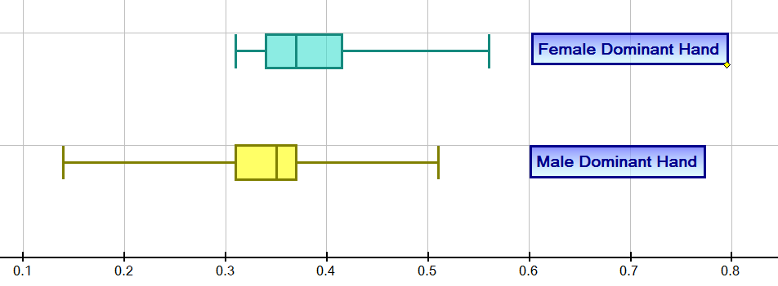

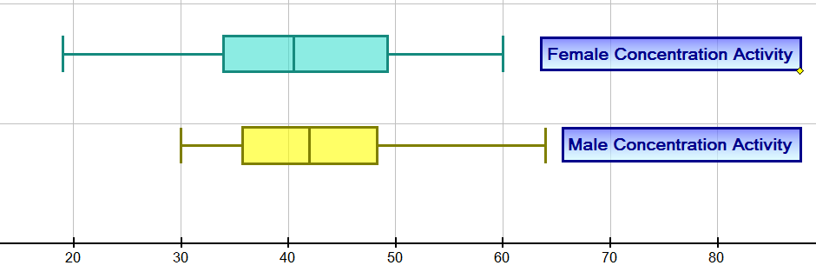

Back to back stem and leaf plots
 | Stem And Leaf
Female Dominant Hand | seconds | Male Dominant Hand
 | 0.0
 | 0.1 | 4
 | 0.2 | 7
9 9 8 8 7 7 5 5 5 4 4 4 4 2 2 2 1 1 0 | 0.3 | 0 1 1 1 1 1 2 2 2 2 4 5 5 5 5 5 6 7 7 7 7 8
5 4 4 3 0 | 0.4 | 0 1 2 5
6 6 | 0.5 | 1
7 | 0.6
 | 0.8

 | Stem And Leaf
Female Concentration Activity | Seconds | Male Concentration Activity
 | 0
9 | 10
8 7 4 2 | 20
9 8 8 4 4 3 | 30 | 0 1 3 4 5 5 5 6 6 7 8 8 8 8
7 7 4 3 1 1 1 0 0 0 | 40 | 1 3 3 3 3 7 7 7 8 9
9 8 6 2 0 0 | 50 | 2 8
1 0 | 60 | 4
7 | 70
 | 80

Back to back stem and leaf plots
 | Stem And Leaf
Female Dominant Hand | seconds | Male Dominant Hand
 | 0.0
 | 0.1 | 4
 | 0.2 | 7
9 9 8 8 7 7 5 5 5 4 4 4 4 2 2 2 1 1 0 | 0.3 | 0 1 1 1 1 1 2 2 2 2 4 5 5 5 5 5 6 7 7 7 7 8
5 4 4 3 0 | 0.4 | 0 1 2 5
6 6 | 0.5 | 1
7 | 0.6
 | 0.8

 | Stem and Leaf
Female Concentration Activity | Seconds | Male Concentration Activity
 | 0
9 | 10
8 7 4 2 | 20
9 8 8 4 4 3 | 30 | 0 1 3 4 5 5 5 6 6 7 8 8 8 8
7 7 4 3 1 1 1 0 0 0 | 40 | 1 3 3 3 3 7 7 7 8 9
9 8 6 2 0 0 | 50 | 2 8
1 0 | 60 | 4
7 | 70
 | 80

Distributions: Dominant hand
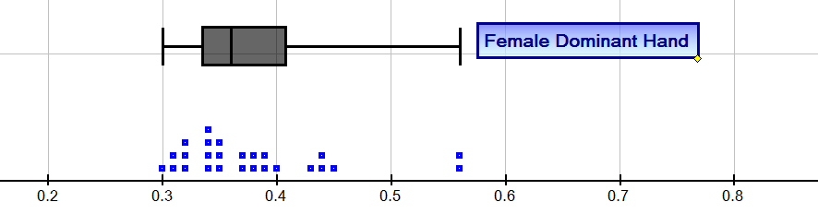
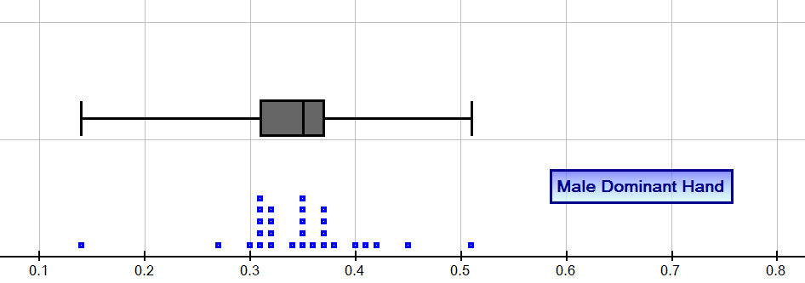

Distribution: Concentration activities
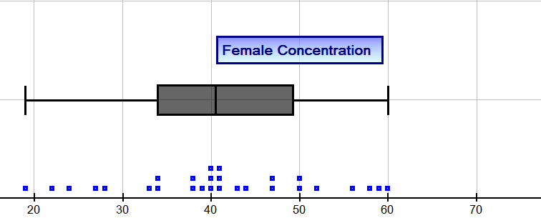

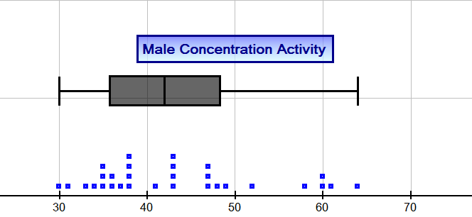

 | Specific behaviours |  | Marks
 | Constructs simple single graphs |  | 1
 | Shows comparative graphs: stem and leaf, histograms or dot frequency |  | 1
 | Uses box and whisker plots to compare male and female attributes |  | 1
 | Presents correct graphs including labelling |  | 2
 | Total |  | /5
Interpretation
Discussion of frequency/proportion, measures of central tendency, removal of outliers and measures of spread
Sample interpretation:
It is clear from looking at measures of central tendency such as mean and median that males performed faster on the reflex activity.
Outliers have been removed from six data points as these would have increased the mean and median for female reflexes.
Females produced better results on the concentration activity with the mean and median indicating females were faster.
The range of scores for males was higher for the reflex activity and higher for females on the concentration activity.
The inter-quartile ranges are higher for females in both reaction times and also the concentration activity.
On the concentration task there was a greater range for the female results which are confirmed by the larger standard deviation compared with the males. The distribution for females is symmetrical but the male distribution indicates a tail of students with larger times indicating a positive skew in the results.
Specific behaviours |  | Marks
Discusses frequency |  | 1
Discusses proportion e.g. median |  | 1
Discusses removal of outliers and effects on mean, median |  | 1
Makes comparisons using measures of spread e.g. range, IQR |  | 1
Makes comparisons using central tendency measures: mean and median |  | 1
Discusses clusters of results in the data |  | 1
Interpretation linked to numerical and graphical data |  | 1
Total |  | /7

Conclusion
Short statement outlining summary of findings
Sample conclusion:
To summarise, while the mean and median scores were better for males than those for females for the reflex activity, female concentration times were better than males with a cluster of males with slower concentration results and a significant number of females with very good concentration results (with the median being lower than the mean).
Reaction times and concentration are important skills for driving but we would need to make a study of other skills or data to answer the question posed. Other skills are important such as general knowledge and adherence to road rules, risk taking behaviour etc. Road accident statistics could also help to answer the question ‘Are males better drivers?’
Specific behaviours | Marks
Makes a valid statement about the results | 1
Relates conclusion back to the original question | 1
Proposes that other data should be collected to help answer question | 1
Provides a concise and coherent summary of the analysis | 1
Total | /4

